Name: Pallavi Chaudhary

Student Code: AF0316472

Batch code: ANP-C6008

Lab Assignment 1

1)Write a program to print your name.

Code:

// TO enter the name

**package** pallavijava;

**import** java.util.Scanner;

**public** **class** Name {

**public** **static** **void** main(String[] args) {

Scanner Sc = **new** Scanner (System.***in***);

System.***out***.println("Enter your name\n");

String Name = Sc.nextLine();

System.***out***.println("your name is " + Name);

}

}

Output:

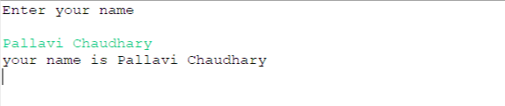

2)Write a program to multiply two floating values and print the product.

Code

**package** pallavijava;

**public** **class** pr2 {

**public** **static** **void** main(String[] args) {

**float** a = 1.2f, b=1.3f;

System.***out***.println("product of two floating values "+a +" and " +b+ " = " +a*b);

}

}

Output

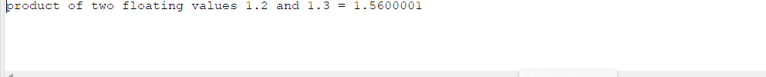

3)Write a program for logical operators.

Code:

//logical operator

**package** pallavijava;

**import** java.util.Scanner;

**public** **class** pr3 {

**public** **static** **void** main(String[] args) {

Scanner Sc = **new** Scanner(System.***in***);

System.***out***.println("ENTER THE VALUE OF INTEGER = \n");

**int** a = Sc.nextInt();

**if** ((a > 0) && ((a % 2) == 0)) // And logical operator

System.***out***.println("Integer number is a positive and even number.\n");

**else** **if** (!(a > 0)) { //Not logical operator

System.***out***.println("Integer number is a negative number or 0.\n");

} **else** {

System.***out***.println("Integer number is odd.\n");

}

}

}

Output:

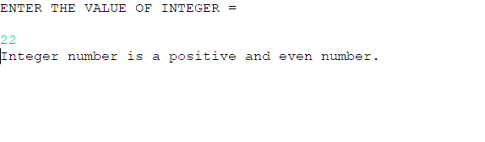

4)Write a program to print size of primitive datatypes.

Code:

//program to print the size of primitive data types

**package** pallavijava;

**public** **class** Size {

**public** **static** **void** main(String[] args) {

System.***out***.println("**************************************************\n");

System.***out***.println("Sizes of primitive data types are following:-\n");

System.***out***.println("1) Integer = " +Integer.***SIZE***+" Bits");

System.***out***.println("2) short = " + Short.***SIZE*** +" Bits");

System.***out***.println("3) Long = " + Long.***SIZE***+" Bits");

System.***out***.println("4) float = "+ Float.***SIZE***+" Bits");

System.***out***.println("5) Double = "+ Double.***SIZE***+" Bits");

System.***out***.println("6) Charater = "+ Character.***SIZE***+" Bits");

System.***out***.println("7) Byte = " + Byte.***SIZE***+" Bits");

}

}

Output:

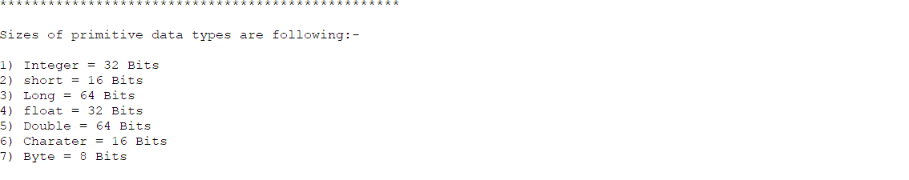

5) Write a program to convert integer value to double and print both values.

Code:

**package** pallavijava;

//typecasting

**public** **class** Narraowing {

**public** **static** **void** main(String[] args) {

// Integer value to double

**int** integer = 1;

**double** Double = (**double**) integer;

System.***out***.println("integer = " + integer);

System.***out***.println("Double = " + Double);

}

}

Output:

